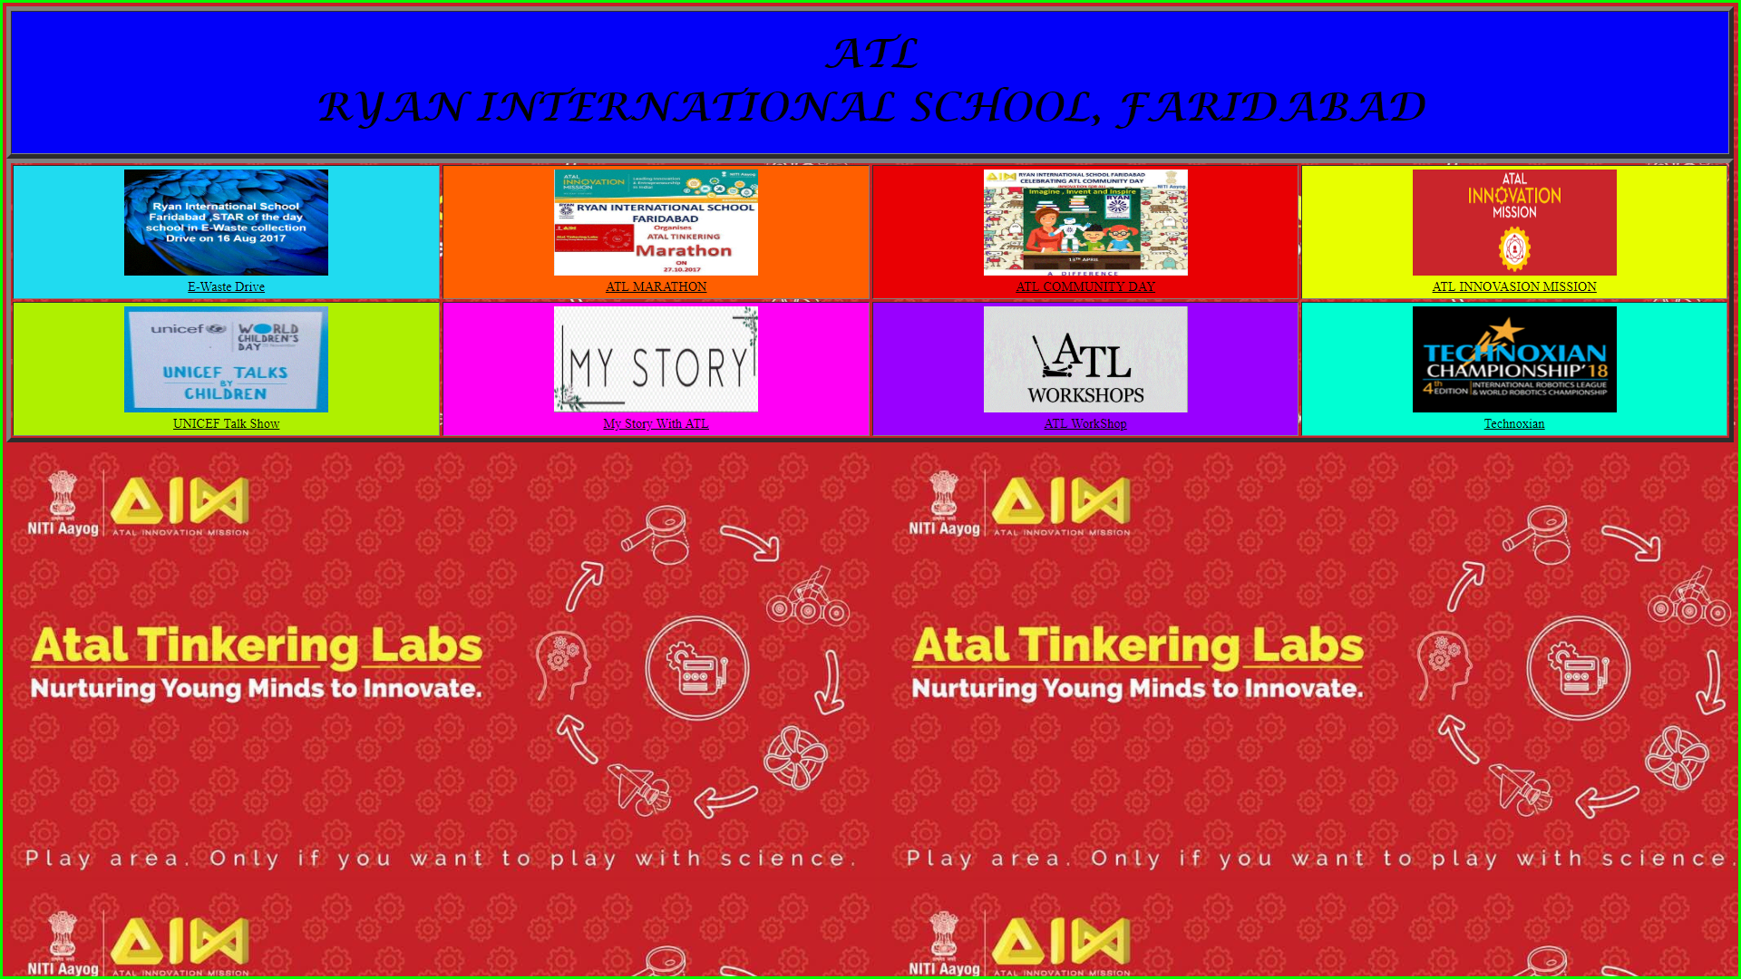

<!doctype html>

<html>

<head>

<title>Main Table</title>

</head>

<body alink="White" vlink="Black" background="ATL1.gif">

<table width="100%" border="5" bgcolor="#0200F9">

<tr>

<th><h1><font size="20" face="Lucida Calligraphy"><i>ATL<br>RYAN INTERNATIONAL SCHOOL, FARIDABAD</i></font></h1></th>

</tr>

</table>

<table width="100%" border="5" cellspacing="4" cellpadding="5">

< Font face="Comic Sans MS">

<tr>

<td bgcolor="#200DBFF" width="25%"><center><img src="E-Waste.GIF" alt="Ryan International School E-Waste drive" width="250" height="130"><br><a href="E-Waste.HTML">E-Waste Drive</a></center></td>

<td bgcolor="#FF5F00" width="25%"><center><img src="ATL Marathon 1.GIF" alt="ATL Marathon" width="250" height="130"><br><a href="Marathon.html">ATL MARATHON</a></center></td>

<td bgcolor="#E90003" width="25%"><center><img src="Community Day.GIF" alt="ATL Community day 18th December 2017" width="250" Height="130"><br><a href="Community.html">ATL COMMUNITY DAY</a></center></td>

<td bgcolor="#E8FF00" width="25%"><center><img src="Innovation Mission.png" alt="ATL Innovasion Mission" width="250" height="130"><br><a href="ATL Innovation Mission.html">ATL INNOVASION MISSION</a></center></td>

</tr>

<tr>

<td bgcolor="#AFF00" width="25%"><center><img src="UNICEF.GIF" width="250" height="130"><br><a href="UNICEF.html">UNICEF Talk Show</a><br></center></td>

<td bgcolor="#FF00F5" width="25%"><center><img src= "Story.GIF" width="250" height="130"><br><a href="My Story.html">My Story With ATL</a></center></td>

<td bgcolor="#9900FF" width="25%"><center><img src="Workshop.GIF" width="250" height="130"><br><a href="ATL WorkShop.html">ATL WorkShop</a></center></td>

<td bgcolor="#00FFD3" width="25%"><center><img src="Techno.GIF" width="250" height="130"><br><a href="Techno.html">Technoxian</a></center></td>

</tr>

</font>

</table>

</body>

</html>

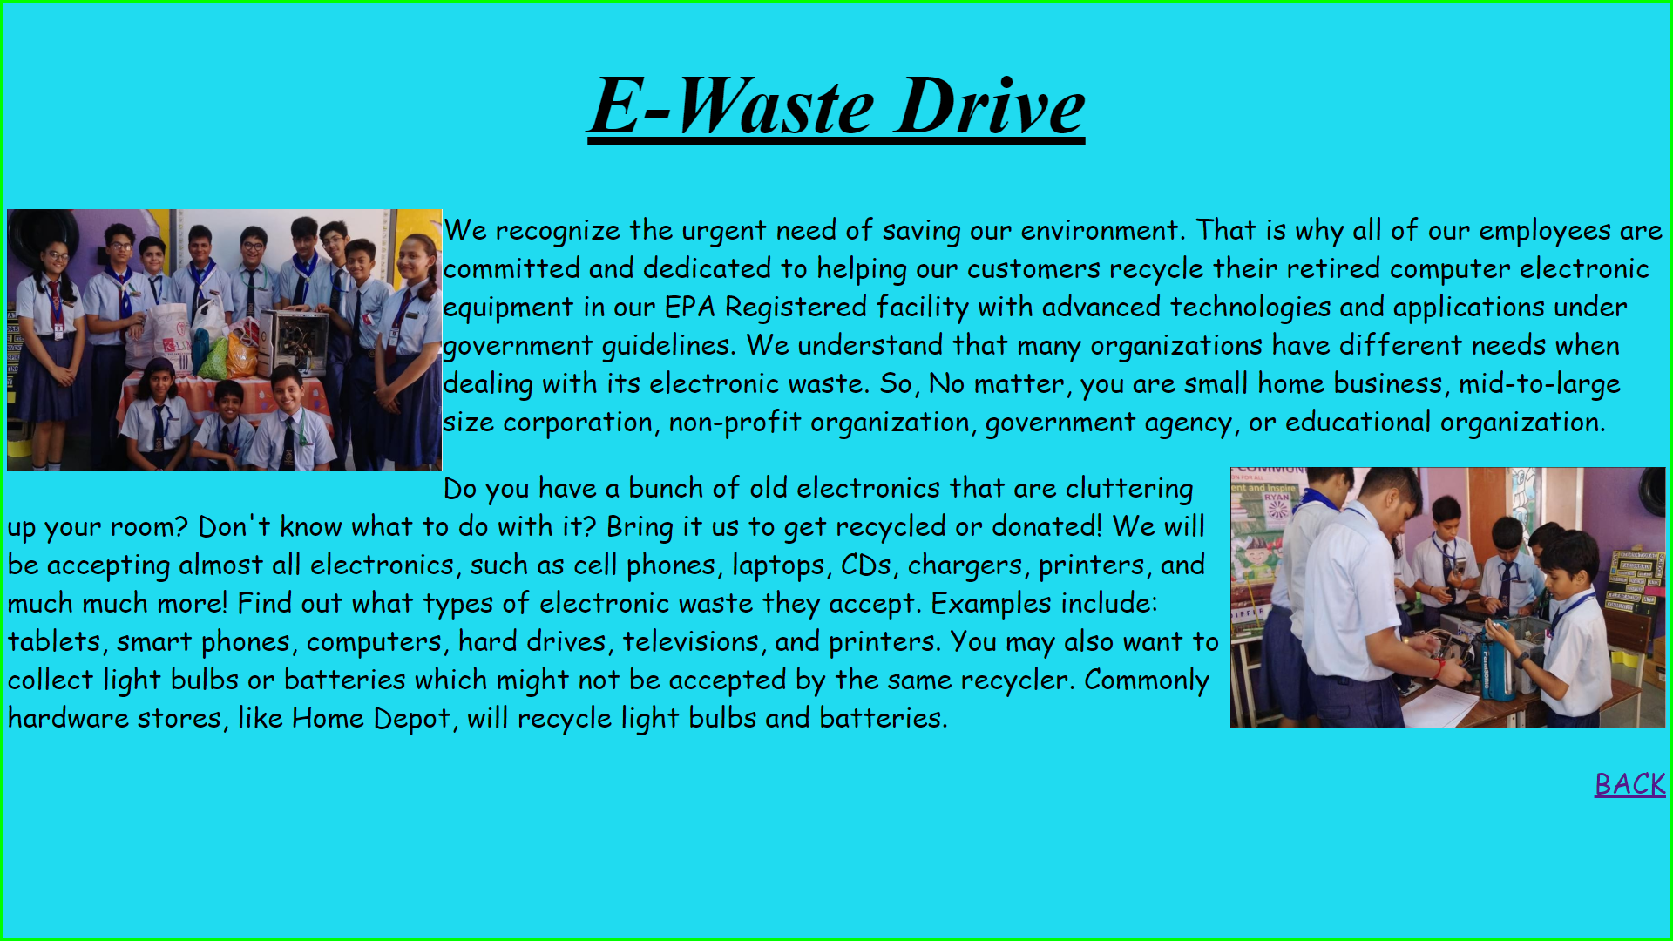

<!doctype html>

<html>

<head>

<title>E-Waste Drive</title>

</head>

<body bgcolor="#200DBFF">

<font size="+5" align="middle" face=><h1> <u> <i>E-Waste Drive</i></u></h1></font>

<font size="+3" face="Comic Sans MS">

<img src="E-waste/E1.JPG" width="500" height="300" align="left" alt="All of us">

<p>We recognize the urgent need of saving our environment. That is why all of our employees are committed and dedicated to helping our customers recycle their retired computer electronic equipment in our EPA Registered facility with advanced technologies and applications under government guidelines.

We understand that many organizations have different needs when dealing with its electronic waste. So, no matter, you are small home business, mid-to-large size corporation, non-profit organization, government agency, or educational organization. </p>

<img src="E-waste/E2.JPG" alt="Segregation" width="500" height="300" align="right" >

<p>Do you have a bunch of old electronics that are cluttering up your room? Don't know what to do with it? Bring it us to get recycled or donated! We will be accepting almost all electronics, such as cell phones, laptops, CDs, chargers, printers, and much much more!

Find out what types of electronic waste they accept. Examples include: tablets, smart phones, computers, hard drives, televisions, and printers. You may also want to collect light bulbs or batteries which might not be accepted by the same recycler. Commonly hardware stores, like Home Depot, will recycle light bulbs and batteries. </p>

<p style="text-align:right;"><a href="Main Table.html">BACK</a></p>

</font>

</body>

</html>